**Generating AWS Access Key ID and Secret Access Key**

Now you can easily access this account using your Access key and Secret Access key of your AWS account. If you dont have one already then go to your account and click on **My Security Credentials**

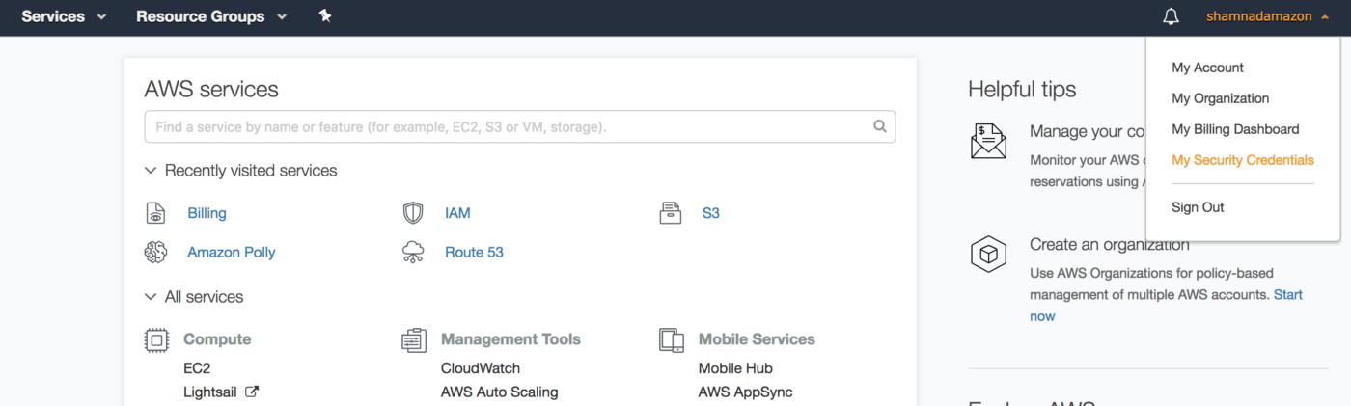

And then select **Access keys (access key ID and secret access key)**section.

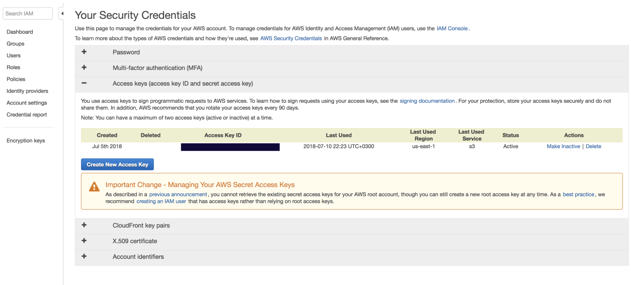

There is an important notification on the section, which recommends you to create an IAM Role instead of creating root access keys.

Click on **Create New Access Key**

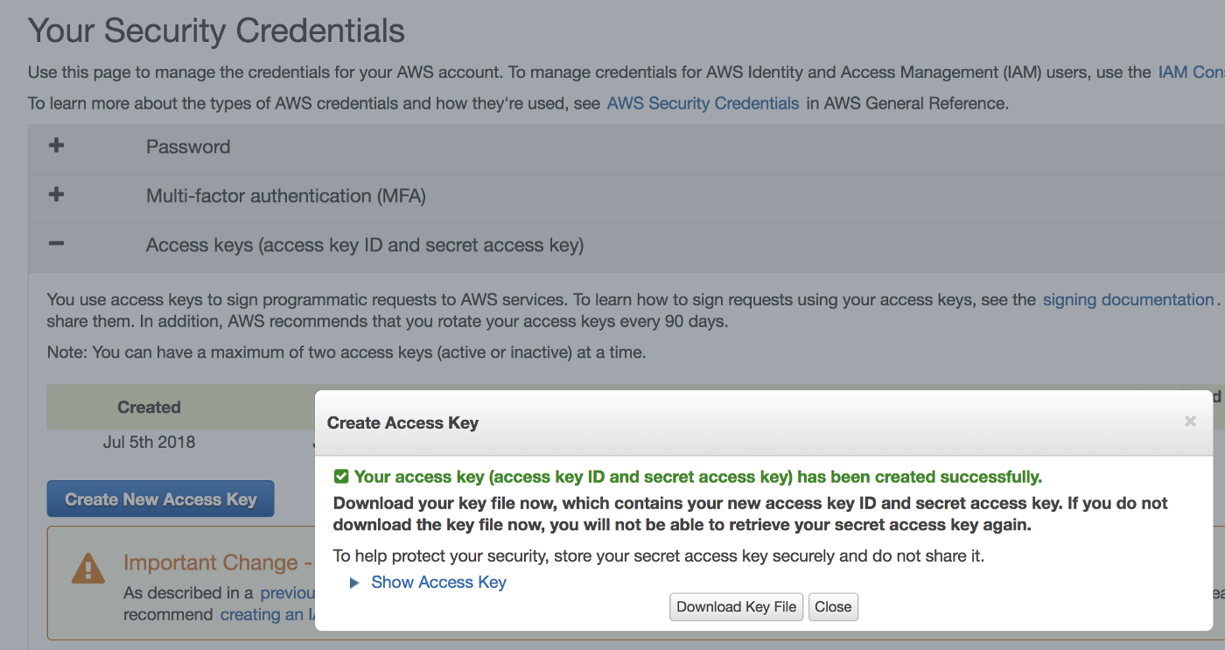

Download the Key pairs to your system for future use.

Click on ***Show Access key*** and you will get your ***Access Key ID*** and ***Secret Access Key.***

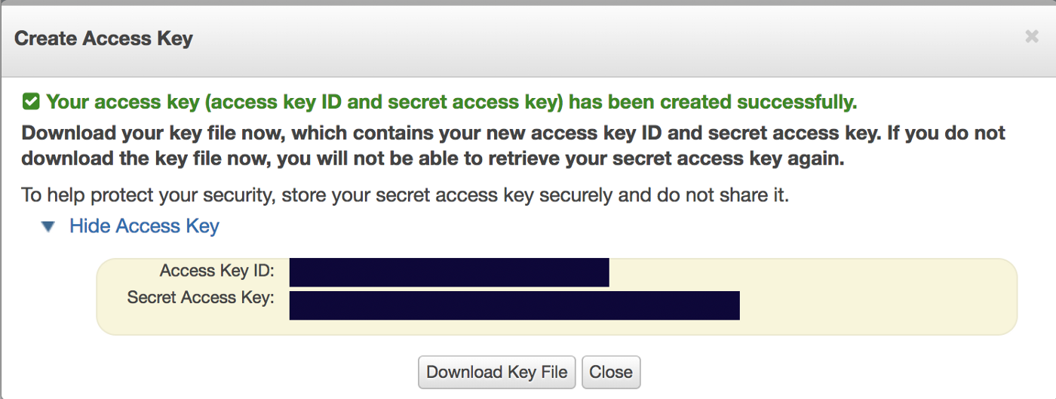

You need to use this***Access Key ID*** and***Secret Access Key*** to connect to your AWS connect and access the S3 bucket.